Problem 42: Endgame

Time Limit: 1 second

A rook endgame is a position in chess where all the pieces were captured, and the only remainning pieces are the 2 kings and 1 rook (in our case, white is the one having the rook).

Although this endgame is winnin for white, it is not that east to actually win this endgame. White needs to know exactly what they need to do. Otherwise, it is easy for black to draw this endgame.

As many may know, the king in chess can move only one square at a time in any of the *8* directions, while the rook can move any number of squares, but only vertically and horizontally.

Chess board consist of *8 x 8* squares, the rows are numbered *1 to 8*, and the columns are numbered *‘a’* to *‘h’*.

The position of a sqaure is denoted by the letter of the column followed by the number of the row. For example *“c5”* is the square in the *3rd*column and the *5th*row.

Given the position of the white king, the white rook and the black king. It is the black’s move. Your task is to to output whether black’s king is under attack by white’s rook or not.

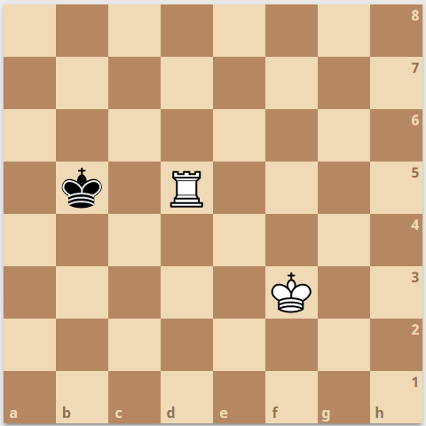

**Input**

First line will be the number of test cases *T*, in each test case you will be given the following.

One line containing 3 strings separated by spaces. The position of the white king, white rook and black king in that order.

**Output**

For each test case output a single line containing “YES” if the black king is attacked by the rook, or “NO” otherwise.

|  |  |
| --- | --- |
| **Sample Input 1** | **Sample Output 1** |
| 1  f3 d5 b5 | YES |